CHRIS ELECTRIC INTERFACE
NAVIGATION GUIDANCE

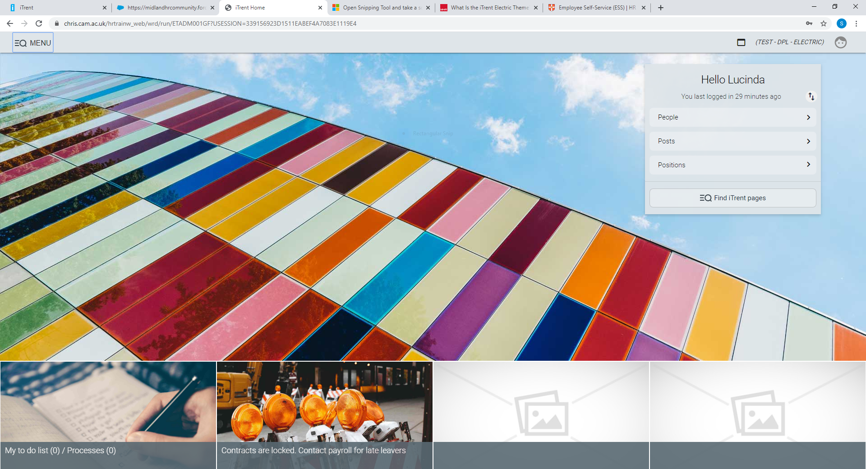

Welcome to the CHRIS Electric Interface
This guidance document outlines basic navigation to move around the new CHRIS Electric interface.

Contents
Introduction 3
What is the Electric Theme? 3
How do I access the new interface? 3
Logging On 3
The Home Page 4
Employee Records 5
Navigating around Electric 6
Within a record 6
Returning to the Home Page 6
New Tab/Window 7
Most used pages shortcut 7
Logging out/Changing roles 7
Further Help 7

Introduction

What is the Electric Theme?
The iTrent Electric theme is the new user Interface for the CHRIS HR and Payroll system.
While nothing has changed in the background of the database, the way we view the data and how we access the screens have. The Electric theme gives a more streamlined and responsive way to access everyday HR Tasks.

How do I access the new interface?
Nothing has changed; you can still access the CHRIS System via the HR System pages using the CHRIS link or via the following address:
https://www.hrsystems.admin.cam.ac.uk/

Logging On
When you click on the link above you will be presented with the logon screen: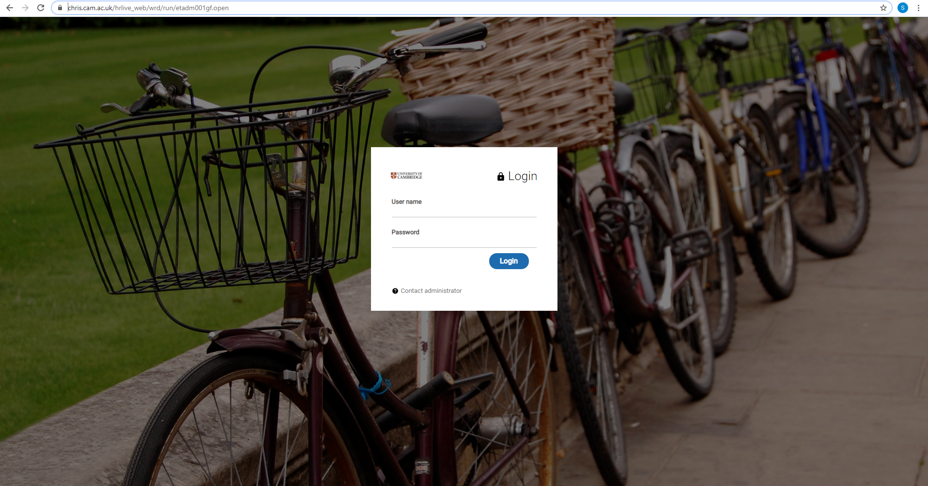
Enter your CRSID and Raven Password and click

The Home Page
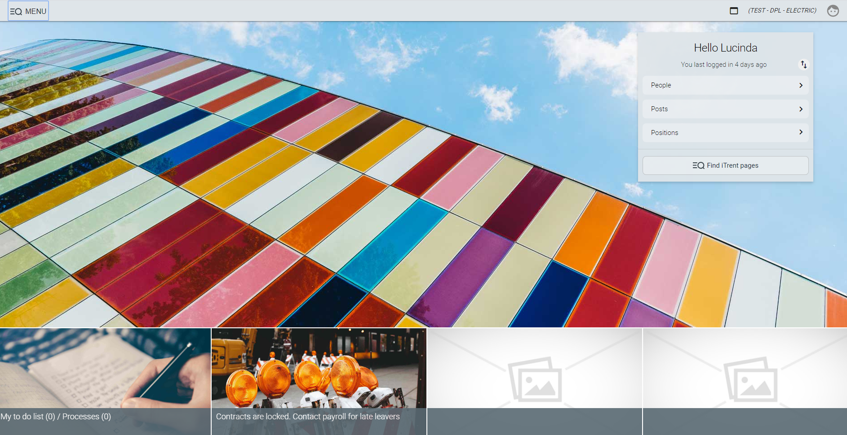
Depending on the role you have been given the menu on the right hand side will hold different sections.
Clicking on a section will activate a left side menu for your search criteria.
This area also acts as your summary screen.
- By using this icon, you are able to enlarge the screen to view the data in detail.
- If you hover over the name, a summary screen will also display.
- An advanced search option is also available by pressing the icon. This menu also allows you to export to excel.
- A scroll bar is available to move around the record.
Note - Here you can search for people by surname, forename and many other parameters using the drop down list box, as you would have in the original version of CHRIS.

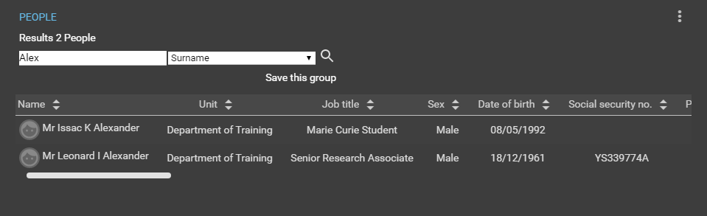
Scroll bar

Employee Records
Once you have selected the employee you wish to view, the record will load.
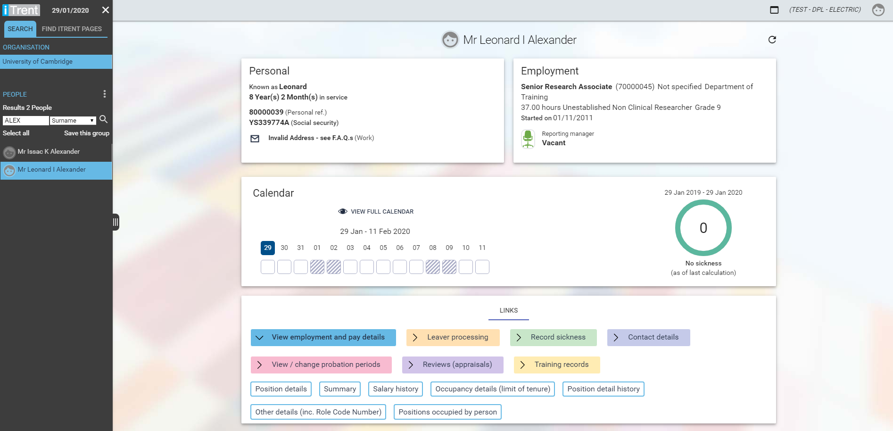
Depending on your access, you will see a screen similar to the one above.
At the bottom of this screen, there is a series of links available. These will navigate you to the screen you wish to see. The left side summary screen will flash when there is a choice to be made- e.g. if the person has more than one role in their employment.
You may be asked to confirm the Effective date at which you wish to review the record – e.g. if you want to see historical data or future records or records at current date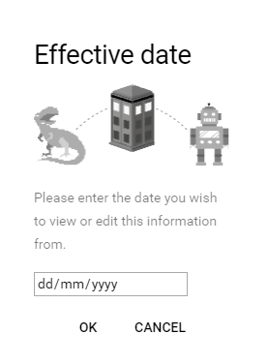
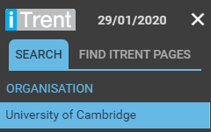
By clicking cancel and this will default to current date. You can also update the effective date at any time by clicking on the date at the top of any screen or the date at the top of the left side menu bar.

Navigating around Electric
If you have finished viewing or entering information against an employee, you can click in the left side menu to conduct another search.

Within a record
Clicking the menu button on top of a screen will reveal the other links available in that folder. You are able to navigate around an employee’s records without leaving the screen.
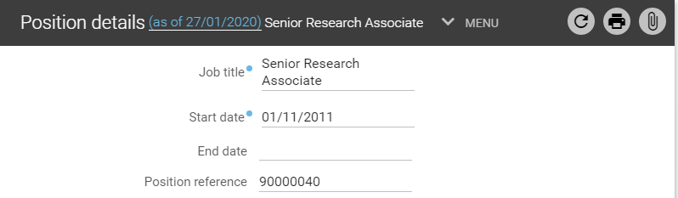
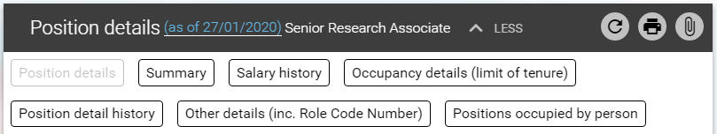

This icon, in the upper right hand side of a screen provides access to UDF Categories if your role allows this. If it is highlighted blue then this will indicate there are Document Attachments linked to this screen.
Click on the header (People screen will display a name, Position screen will show position title etc.) at the top of the screen, if you wish to go back to the Person record summary screen where you can choose different link with in the same record.

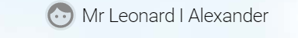

Returning to the Home Page
To go back to the Home Page Click this icon in the upper left hand corner of the screen.

New Tab/Window
You can have multiple views open within a single browser window by using this icon . When clicked, the icon will open a new CHRIS session in a new browser tab. This will always open at the Home Page. If you log out of one view, all the other views open, will also be logged out. When a new view is opened, you can switch to a different role.

Most used pages shortcut
Once you have been using Electric a while, CHRIS will build up a log of your most used pages. You may find it useful on occasion to jump straight to a particular screen you want to view. To do this you can click on the left side menu ‘Find iTrent pages’. Once clicked it will ask you to submit a search criteria and take you directly to the page requested.
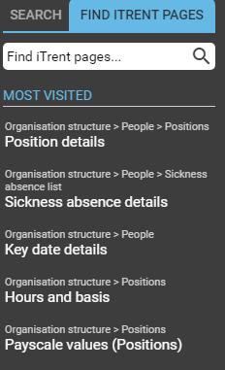

Logging out/Changing roles
When you are finished using CHRIS, click on in the top right hand corner of the screen. Choose the option to log off. A pop up box will appear; click and you will be logged out of the system. If you have access to other roles, this will display a list for you to select another role.

Further Help
During the roll out period, if you require further assistance, or you think we can add anything to this document please contact the Electric Team at HRCHRISElectric@admin.cam.ac.uk
For anything else or after 27th February 2020 please contact CHRIS.Helpdesk@admin.cam.ac.uk

