Contents

1. Log-in 2

2. Re-setting Raven Password 5

3. Viewing/Amending Details 8

4. Viewing a Payslip 11

1. Viewing a P60 14

6. Absence 17

5. Logging Out 19

Log-in
- To access Employee Self Service click on the link from the HR Systems Home Page:
http://www.hrsystems.admin.cam.ac.uk/
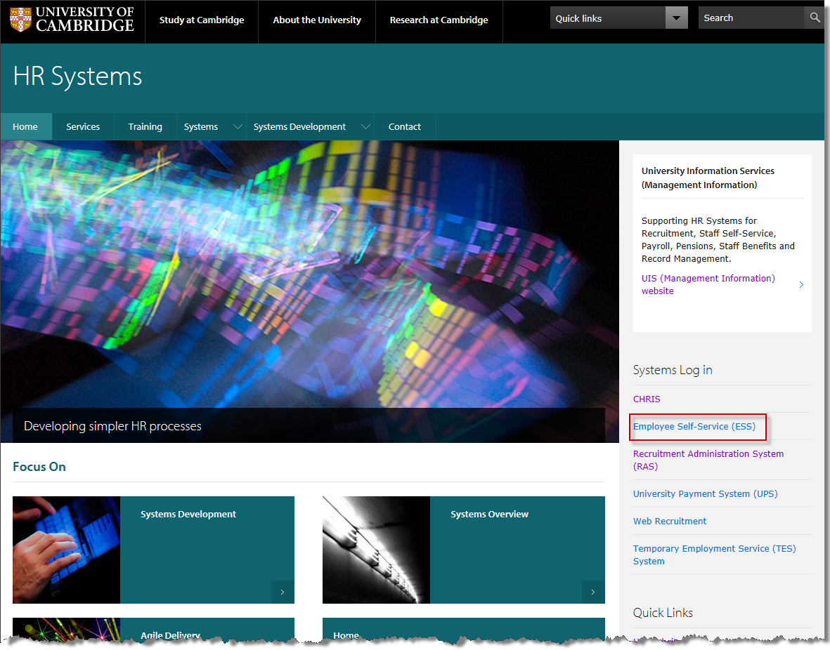
- The Login Screen will be displayed
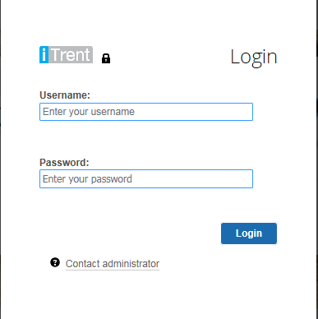
- Enter your Username and Raven Password.
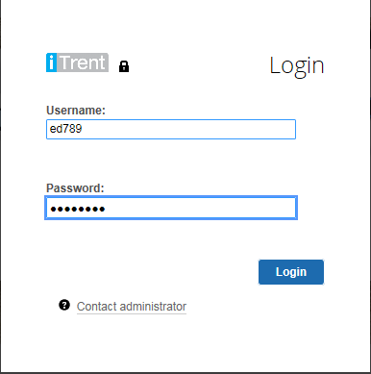
- The home Employee Self Service Screen will be displayed
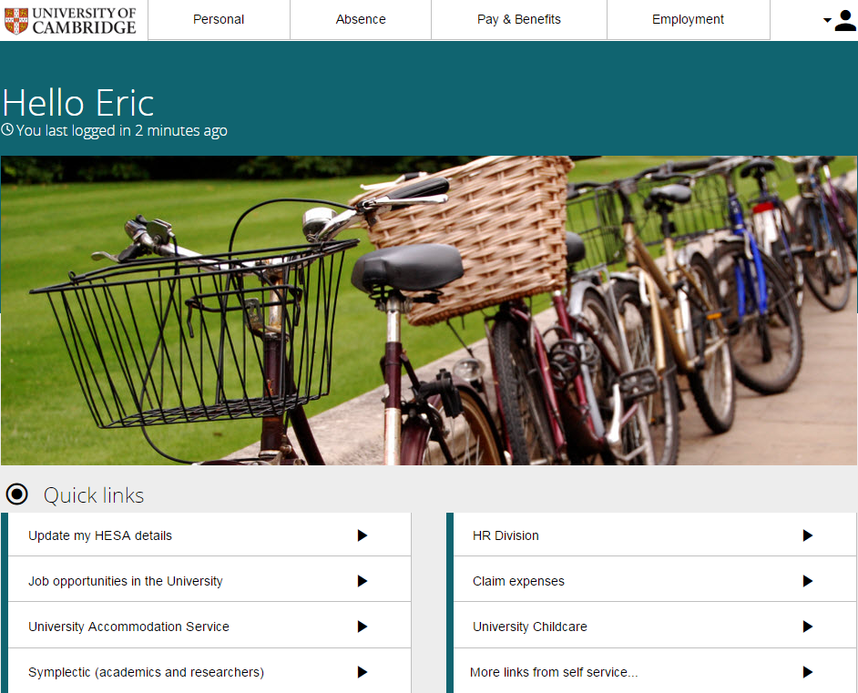
- To return to the ESS Home screen at any time click on the University of Cambridge logo at the top left of the screen.

Re-setting Raven Password
- If you receive an Invalid login message you will need to re-set your Raven password
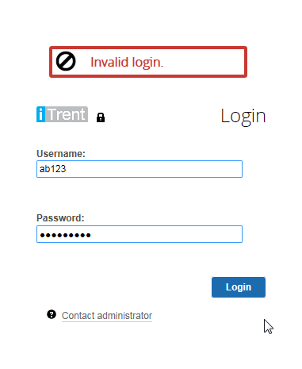
- Click on the Contact administrator button
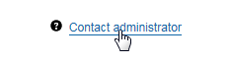
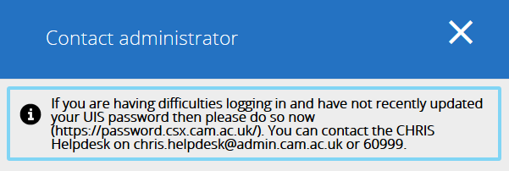
- Navigate to https://password.csx.cam.ac.uk and select the Change Password button
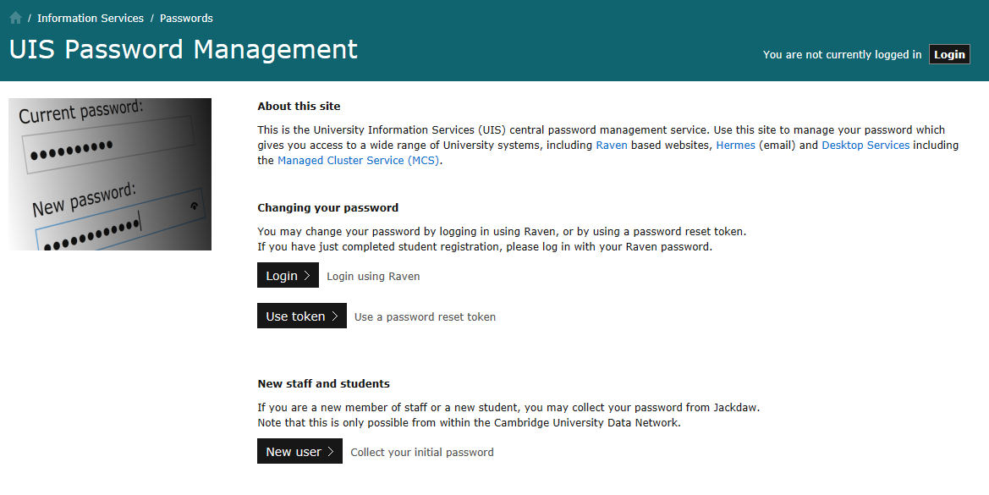
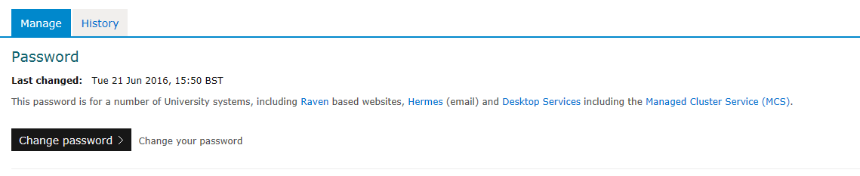

- Follow the prompts to enter your current password and new password.
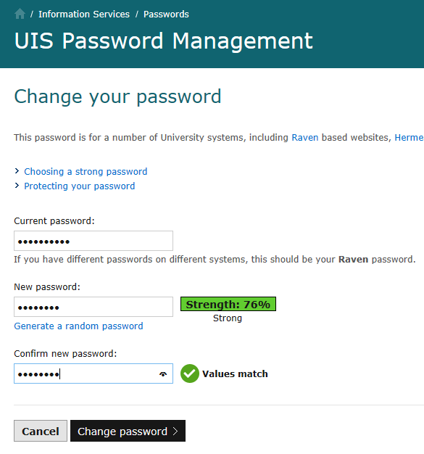

Please note that it may be possible to re-enter your existing password as your new password providing it is of sufficient strength.

Viewing/Amending Details
- Select Personal from the navigation bar.
- Personal details, contact information and emergency contact information will be displayed.
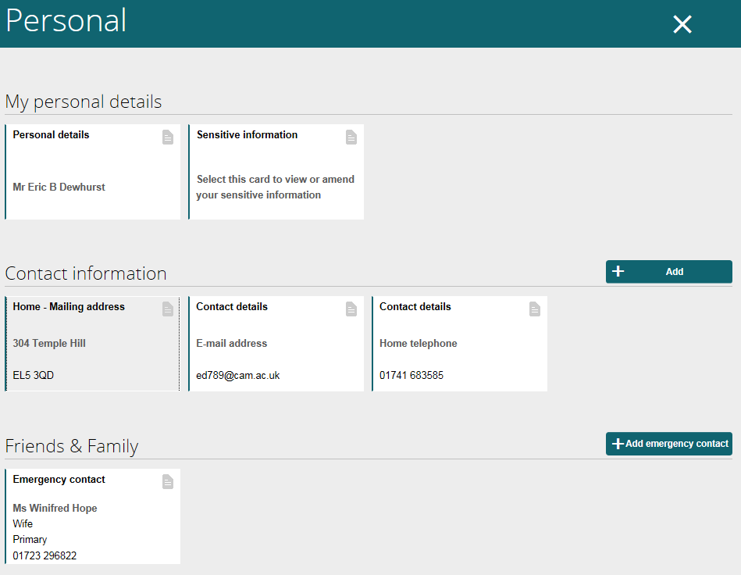
- Click on an item to view or correct current information.
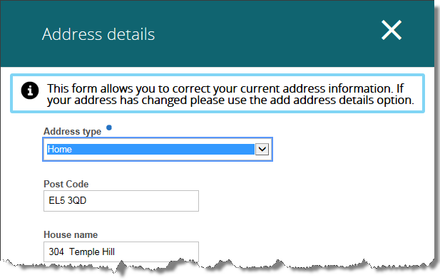
- Use the Add button to add additional Contact Information

- Select Add address, or Add contact details as required
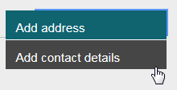
- Type the new details and click on Save
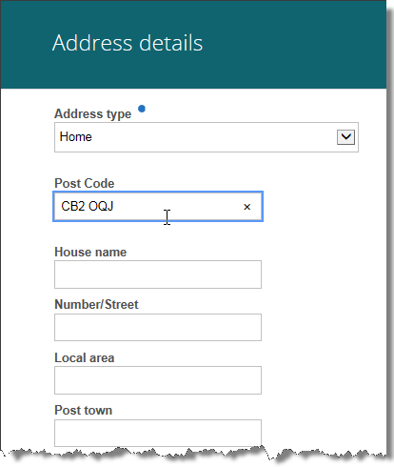
- Confirmation will be displayed.
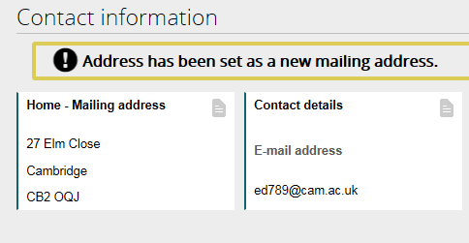

Viewing a Payslip
- Select the Pay and Benefits option from the menu bar
- Payslip and P60 information will be displayed.
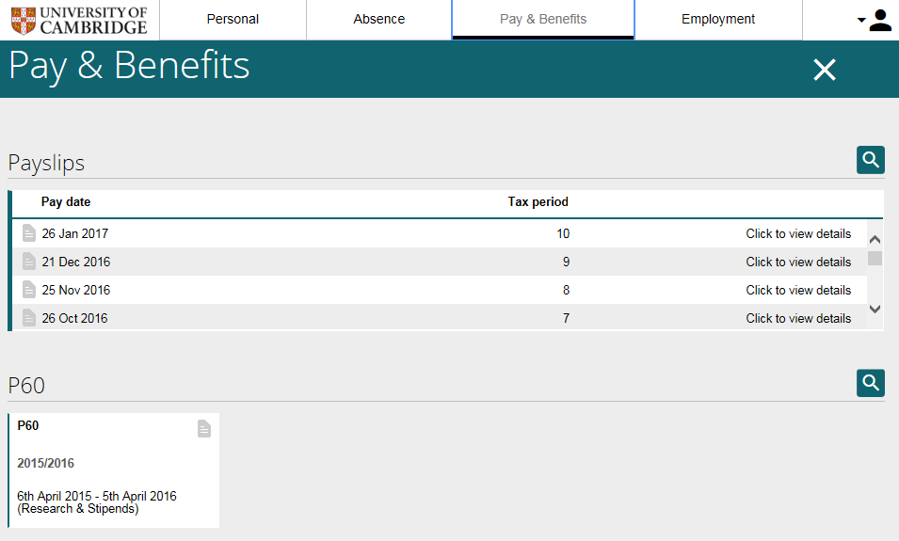
- Select the ‘Click to view details’ option to the right hand side of the Payslip you wish to view
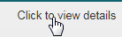
- The selected Payslip will be displayed.
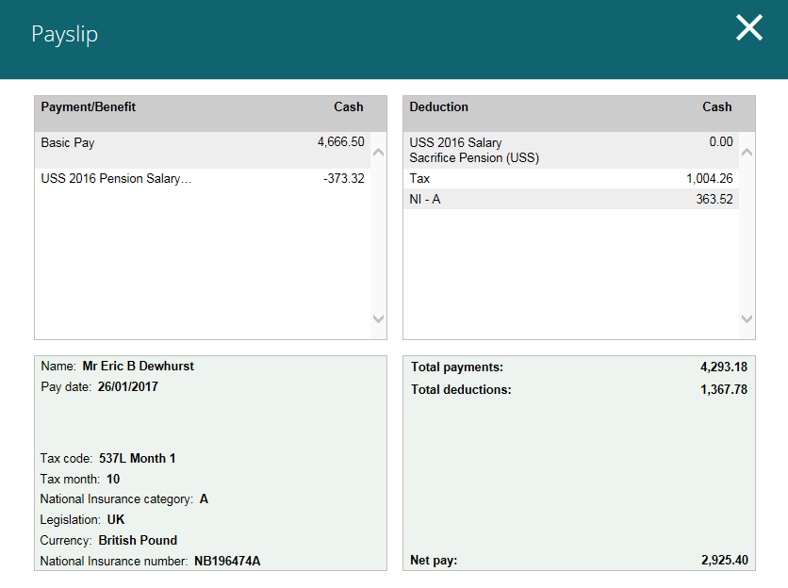
- The Payslip can be printed or downloaded and saved.
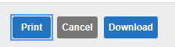
- ESS will automatically display the last 12 months payslips. To view Payslips from more than a year ago click on the magnifer.
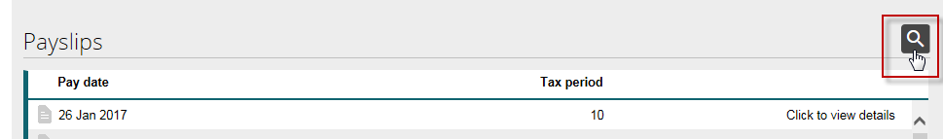
- Enter the date range you wish to view in the format dd/mm/yyyy.
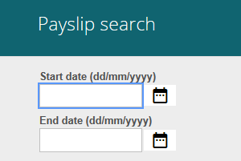
- Or use the calendar to select date(s)
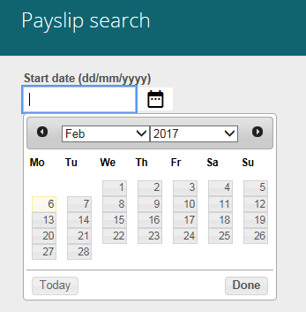

Viewing a P60
- P60 information will be displayed as a page:
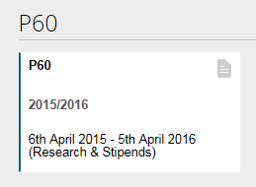
or a list if you have more than 4 years information:
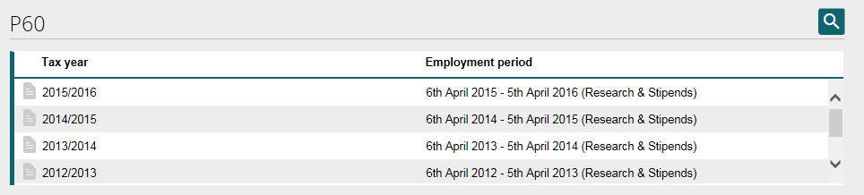
- When you select P60 this message will be displayed
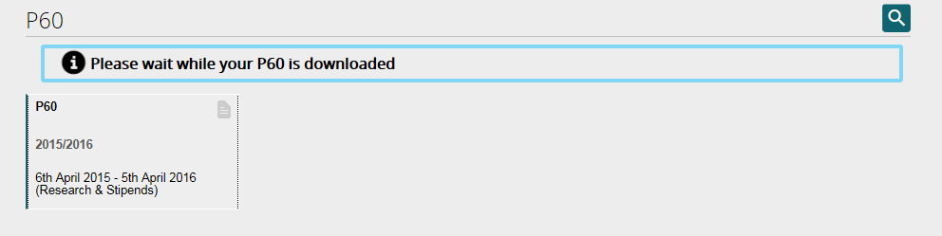
- Followed by options to Open or Save
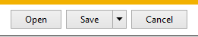
- If you wish to view a P60 from more than 6 years ago, select the magnifier
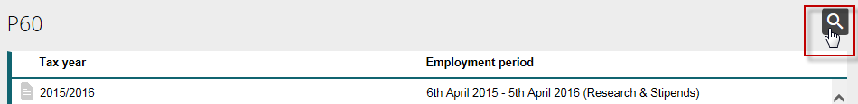
- Enter the Start Year and End Year
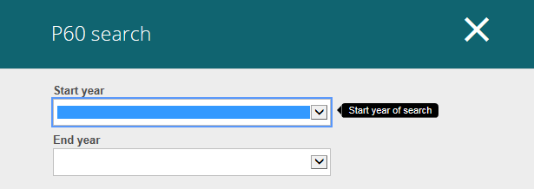
- Then click on Search.
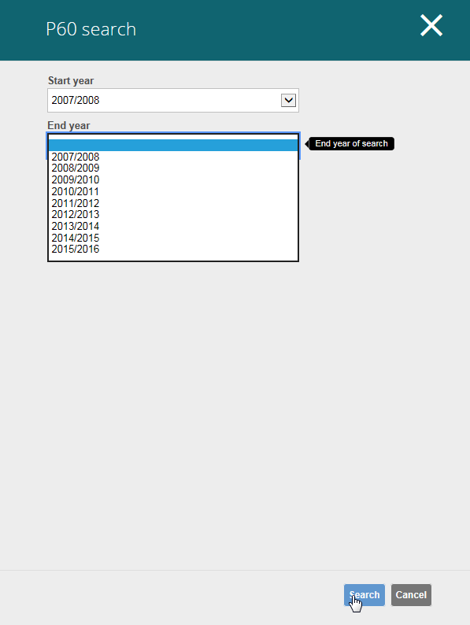

Absence
- To view absences in Employee Self Service select the Absence option from the menu bar.
- Absence history will be displayed
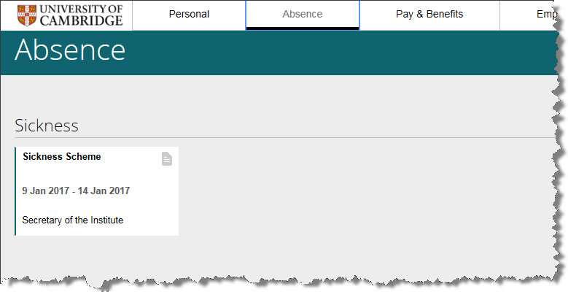
- To view details select the page icon to the right hand side of the absence you wish to view.
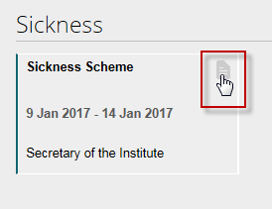

- Absence details will be displayed.
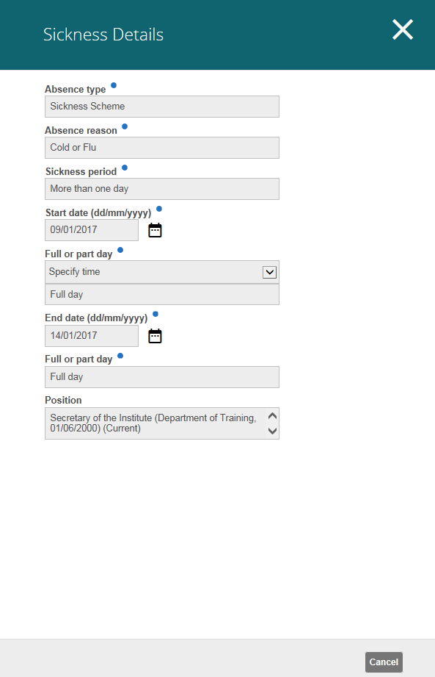

Logging Out
To logout from Employee Self Service select the drop-down arrow to the left of the person icon and select Logout.


